Proposal to ComfortDelGro Insurance Brokers Pte Ltd for Motor Claims Administration System

Copyrights & Document Information

Proprietary Notice

The materials in this document are proprietary to Ebix. The proposal is submitted to ComfortDelGro and in accepting this proposal, it is deemed that ComfortDelGro has agreed to abide by the confidentiality nature of this proposal. The reproduction or distribution of any part of the enclosed information will not be allowed without prior written permission of Ebix. Any other parties other than ComfortDelGro employees who review this proposal will be deemed to have obtained Ebix’s proprietary information without authorization and may be subject to legal actions.

Copyright © 2014. All Rights Reserved.

Submitted by:  Ebix Singapore Pte Ltd  1 Pickering Street  #06-03 Great Eastern Centre  Singapore 048659 | Contact:  +6565936589  Mr. Yip Cheng Choon  Vice President – EbixExchange Asia  DID: +65 65936589  H/P: +65 98323719  E-mail: chengchoon.yip@ebix.com

Table of Contents

1.0 EXECUTIVE SUMMARY
1.1 Introduction
1.2 Solutions Overview

2.0 COMPANY INFORMATION

2.1 Corporate Information

3.0 SCOPE OF WORK AND DELIVERABLES

3.1 Proposed Scope of Work
3.2 Project Deliverables
3.3 Assumptions
3.4 Network Architecture
3.5 System Architecture

4.0 PROPOSED IMPLEMENTATION PLAN

4.1 Project Approach and Work plan
4.2 Proposed Project Organization
4.3 Roles and Responsibilities

5.0 PROJECT PRICING – SOFTWARE LICENSE AND SERVICES

- Executive Summary

Introduction

Ebix is pleased to have the opportunity to present this proposal to ComfortDelGro Insurance Brokers Pte Ltd (CDGI) for implementation of its Claims Administration System.

Solutions Overview

Ebix’s proposed solution provides a fully integrated web-based modular Claims Administration System customized to meet CDGI’s requirements. The key Modules and a brief summary of the functions within each Module:-

- Online Filing of Motor Accident Module
  - this Module enable Accident Reporting Centres (District) to submit accident details online
  - all required attachments, including images and Sketch Plan of the accident are uploaded online through this module
  - this module is integrated to the Claims Administration Module and this process takes away manual re-entry of the accident details.
  - Since it is integrated to the Claims Administration Module, certain validations can be incorporated into this module to ensure that proper data are processed into the Claims Administration System
  - Enquiry functions are available for Users to view and track all e-filed accident cases
  - Reports specific to this group of users will be available in this module and there is no necessity to access the Motor Claims Administration Module
  - A System Administration function to set access rights for Users and User Groups.
  - UI will be HTML 5 compliant
  - The application will be subject to Penetration & Security testing and the report will be made available to CDGI

- Motor Claims Administration Module
  - Motor Claims processing – the functionalities covered are:-
    - New claims registration
      - Capturing all new accident cases with segregation between Own Damage, Third Party and Claims Expenses details. Each claim type has its own reserves
      - Handles multiple claimants involved in a claim
      - Overall reserve for each accident
    - Claims Movement
      - updating changes in reserves
    - Claims Settlement
      - Claims settlement approval process
      - The approval process is validated against Authority Limits set up in the System Administration function
    - Claims Re-open
      - Allows re-opening of closed cases arising from new developments on the case
    - Claims Recovery
      - A separate function to record and track recoveries against third parties. Basic details pertaining to the recovery defaults from the claims details
    - Worklist
      - This is a workflow set-up that handles work assignment, transfers and case escalations procedures.
      - Each tasks will be calendar driven

  - System Admin
    - Key master control tables are –
      - User Group set-up
      - User Role Type
      - User set-up
      - Loss Type
      - Loss nature
      - Workshop Master
      - Adjuster Master
      - Surveyor Master
      - Solicitor Master
      - Consultant Master
      - Vehicle Make & Model
      - Claims Close Reason Master
      - Claims Re-open Master
      - Currency Master
      - Exchange Rate Master
      - Insurer Master
      - Authority Limits Master
      - Insurance Policy Master
      - GST Setting Master

  - Other functionalities/features
    - The database will be multi-language enabled
    - Based on agreed formats and letter types, the system will generate standard formatted letters
    - Archival functions to improve system performance
    - Pre-agreed database tables will be made available to CDGI to query and develop own reports using Microsoft SQL Server query tools and a section will be set aside for CDGI to upload these reports. To facilitate such capabilities, Ebix will make available relevant database schemas. Special consideration will be taken to segregate databases specific to Buses or Taxis
    - UI will be HTML5 compliant
    - The application will be subject to Penetration & Security testing and the report will be made available to CDGI
    - A file upload function will be considered to handle claims data files that will be provided insurers.

An overview of the Proposed Solution –

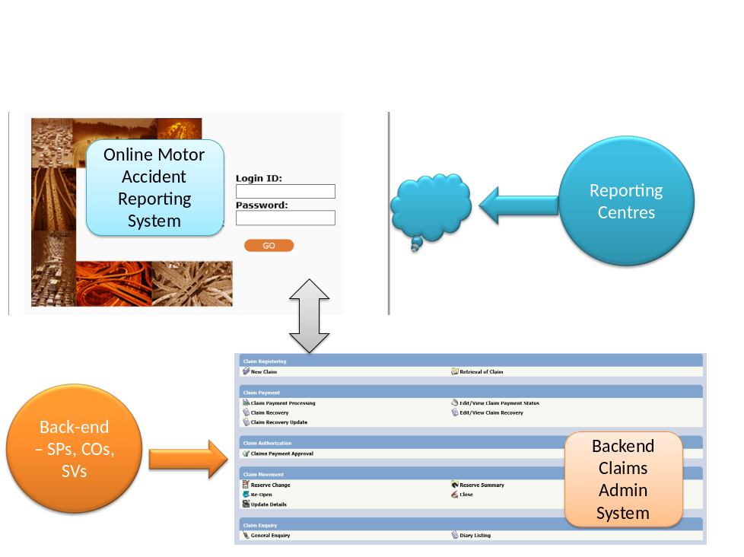

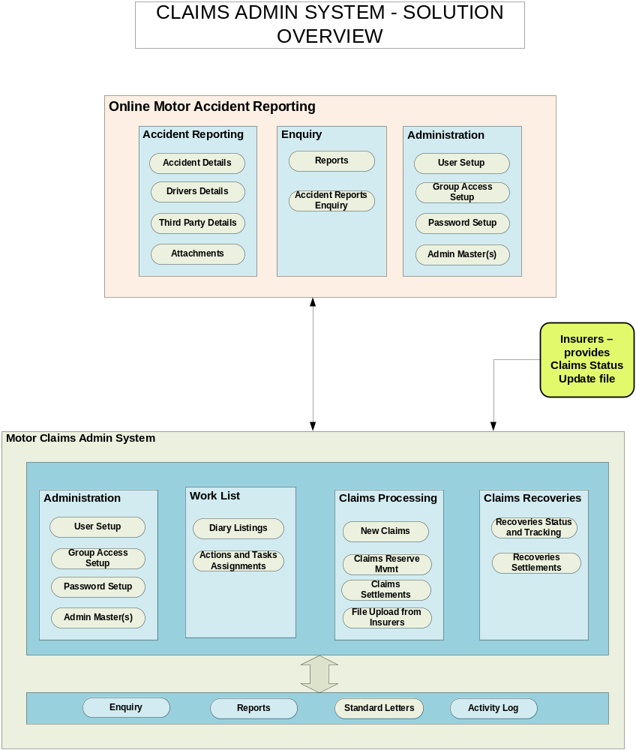

- Company Information

Corporate Information

Background

Ebix is a leading international supplier of software and e-commerce solutions to the insurance industry. Ebix provides a series of application software products for the insurance industry ranging from carrier systems, agency systems and exchanges to custom software development for all entities involved in the insurance and financial industries. Ebix powers businesses in more than 50 countries across six continents.
Ebix’s goal is to be the leading backend powerhouse of insurance transactions in the world. The Company’s technology vision is to focus on convergence of all insurance channels, processes and entities in a manner such that data can seamlessly flow once a data entry has been made.
With a recurring revenue base of approximately 80%, Ebix strives to work collaboratively with clients to develop innovative technology strategies and solutions that address specific business challenges. Ebix combines the newest technologies with its capabilities in consulting, systems design and integration, IT and business process outsourcing, applications software, and Web and application hosting to meet the individual needs of an organization.
The Company has its headquarters in Atlanta (GA), and has domestic operations in Los Angeles (CA), San Diego (CA), Walnut Creek (CA), Hemet (CA), Pittsburgh (PA), Miami (FL), Park City (UT), Herndon (VA), Columbus (OH), Dallas (TX) and Portland (MI). The Company also has offices in nine other countries – Australia, New Zealand, Singapore, China, Japan, Brazil, Canada, United Kingdom and India.
Our vast customer base includes over 100 Insurance companies, TPAs, Banks, Financial Advisors and more than 300,000 Brokers/Agents, in addition to a few hundred corporate clients. This includes an impressive blue-chip account base consisting some of the world’s largest and most respected insurance companies as well as a large community of insurance professionals. Targeting a nearly sixty billion-dollar market segment in US alone, Ebix has ample growth opportunities simply by leveraging its existing customer base and outstanding reputation for high-quality services.
Led by a seasoned group of professionals that add up to a few hundred years of executive leadership with fast-growing, successful organizations, Ebix is poised to sustain its leadership and develop an even larger market presence.

We are ranked the 3rd Best Investment and the 3rd Fastest Growing Company in the world by FORTUNE Magazine and 1st in IT Sector.

Ebix Singapore is the Registered International HQ of Ebix, Inc and is an approved IHQ status awarded by Singapore’s Economic Development Board.

Singapore Office is also the Global Centre for Product Management
- Ebix Singapore owns all the Intellectual Property of Ebix Software applications
- It is also the Product Management Centre for all software development within Ebix

Our Products and Markets

Ebix’s products cover the entire Insurance Industry vertical.

- Scope of Work and Deliverables

Proposed Scope of Work

The Scope of Work in respect of Claims Admin System is defined in Appendix 1.

For this service, our Scope of Work is as follow –

 | Activities | Done By
1 | System Requirements Specifications | Ebix with CDGI
2 | Functional Specifications document | Ebix and sign-off by CDGI
3 | System Reconfiguration | Ebix
4 | System testing and readiness for UAT | Ebix, who will also share its test cases with CDGI to facilitate UAT
5 | System training and development of User Manuals for Users and System Administrator | Ebix to conduct separate training for CDGI users and workshops users.
6 | UAT | CDGI
7 | Bugs fixes from UAT | Ebix
8 | System acceptance and sign-off | CDGI

Project Deliverables

The following documentations will be delivered as part of the scope of this project.

Requirements Definition Phase
- User Requirements Documentation
- User Requirements sign off
- Project Meeting Minutes

Solutions Design Phase
- Functional Specifications
- Screen Prototyping
- Screen Prototype sign off
- Project Meeting Minutes

Customization Phase
- Application Reconfiguration – refer to Appendix 1
- User Training – End Users and System Administrator. Training will be conducted in English. End User Manuals will be provided in English
- User Acceptance Testing (UAT) and Bugs Log
- Project Meeting Minutes
- UAT sign off

Assumptions

Project Management Assumptions
- All key design and decision made by the project team will need to be signed off. CDGI is expected to turnaround these sign-off documents within 3 working days to ensure smooth execution of the project, in view of the time line.
- Documents signed-off (by Ebix and CDGI) during the project will super-cede any previous agreements made between the 2 parties.

Resource Assumptions
- CDGI will provide Ebix with ready access to all existing documentation of the current processes and system, where necessary.
- CDGI will ensure the availability of users/CDGI project management in accordance with the project schedule. Their availability is critical in ensuring that the project stays on schedule.
- Furthermore, CDGI will commit resources in the Requirements Definition Phase.
- The relevant personnel, with access to the existing systems are available during the course of the project
- CDGI will ensure the availability of necessary personnel (e.g. project sponsor, steering committee member, CDGI PM, users, sys admin, etc) during the course of the project.
- CDGI will provide all infrastructure level support (network, connectivity, project room, access to systems).
- CDGI will provide all software and hardware (other than those included in this proposal) required for development and production. This includes the provision of a project development site.

Scope Assumptions
- This is a single site implementation and deployment in CDGI only
- The proposed system will be in English language. All project documentations provided will be in English, except specifically indicated in the Scope of Work.
- It is assumed that the data needed are readily available in database format. If such data is not available, CDGI will make necessary action to have these data made available for the creation of such document.
- Ebix will carry out system Performance Testing using Microsoft tools
- Software used during the implementation of this project will be based on the following –
- Microsoft .NET 4.0
- ASP.NET C#
- Operating System – Windows 2008 – current CDGI License
- Microsoft SQL 2008 – current CDGI License
- There will be no changes in the version of the software during the course of the project unless mutually agreed by CDGI and Ebix.
- We recommend that both O/S and SQL 2008 be upgraded to R2 version, if possible.

Network Architecture

The following generic diagram depicts a recommended set-up for high availability level network infrastructure, within which the Claims Admin System will be deployed. The set up of the infrastructure for this project and its final composition will be the responsibility of CDGI Infrastructure Team.

PROPOSED CLAIMS SYSTEM NETWORK DIAGRAM:

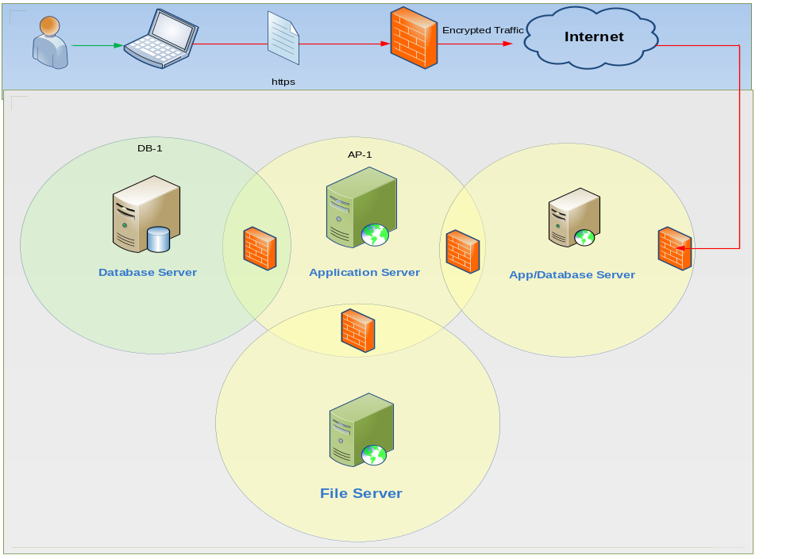

Notes:
- App/Database Server for Online Claims Registration accessed by Depots and Workshops for Accident Reporting
- Claims Processing staff access Claims System via LAN
- File Server – centralized depository of all file attachments and images
- Hard Drive size would vary based on volume of data requirements for an implementation.
- Separate server set-up may be done for Staging/Testing Environment

System Architecture

The following is our System Architecture for Claims Admin System.

System Architecture

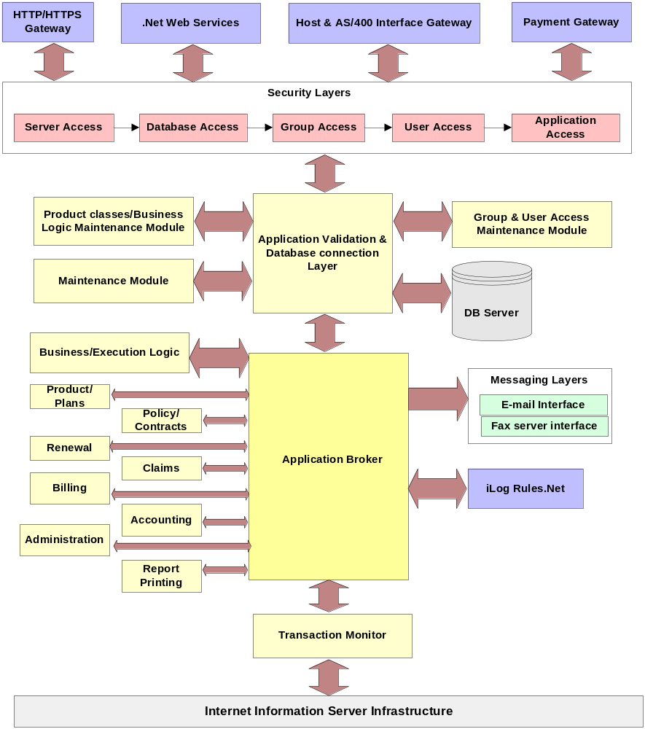

The design is based on 3-tier architecture as shown below

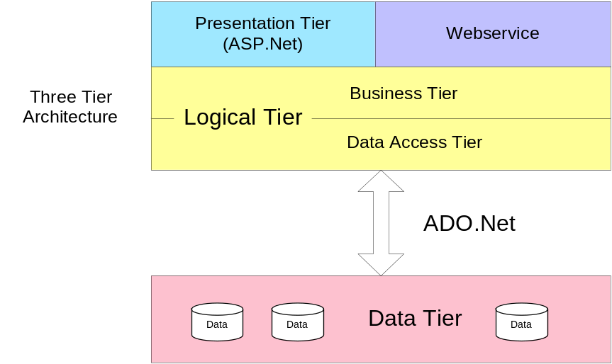
1. Data Tier
This Tier is responsible for retrieving, storing and updating information. We consider stored procedures as a part of the Data Tier. Usage of stored procedures increases the performance and code transparency of an application
2. Logical Tier
This is the brain of the 3-Tier Application. We separate the Business tier from Data Access Tier for the following purposes:
- Increase code transparency.
- Any changes in the Data Access Tier will not affect the Business Layer, and this will enhance the scalability of the application.
2.1 Business Tier
This sub tier contains classes of various business logics. This tier does not have a direct link to any GUI controls and database access. The classes of Data Access Tier will supply the require information to this sub tier for database interaction.
2.2 Data Access Tier
This tier acts as an interface to Data Tier. Webservice will be used in this tier to retrieve and store information.

3. Presentation Tier:
This Tier is responsible for communication with the users and third parties’ webservice. It will use objects from Business Layer to response to any GUI raised events.

- Proposed Implementation Plan

Project Approach and Workplan

Ebix will follow this delivery Methodology to Thai Re:-

Project Management
Technical Support & Infrastructure
Change Management
Definition
&
Operations Analysis

Solutions Design

Build

Transition/
Production

GO!

Project Schedule

A project schedule will be provided upon completion of System Requirements Specifications phase. Our current estimated timeline is 5 months from project confirmation, subject to carrying out detailed business requirements and excluding time frame for carrying out System Penetration Security Testing by third party vendor.

Proposed Project Organization

Key to the success of the project is good teamwork with active, full-time participation of the CDGI’s executive management, IT personnel, as well as user representatives. The following chart illustrates the recommended project organization.

Proposed Project Organization

Figure 1 - Proposed Project Organization
Project Steering Committee

Project Managers-
CDGI and Ebix
Development Team
Business Team / User Representatives
Project
Team Lead

Roles and Responsibilities

Steering Committee

Roles
- Provide executive guidance and direction to the team
- Monitor and validate changes to the business case
- Are accountable to the Board of Directors
- Conducts project audit and review
- Ensures the organisation alignment

Responsibilities
- Approve the scope, approach and resouces required for systems projects as well as the project business case
- Determine and communicate project priorities
- Review and monitor project status and budget
- Approve all major project outputs, especially where changes to the business case is concerned
- Resolve, through consensus, all major project issues spanning the entire organisation

Project Management Team

Roles
- Provides leadership, direction and management of the project
- Is accountable to the Project Steering Committee (PSC)

Responsibiliites
- Determine the scope, approach and resources required for systems projects
- Organise, plan and track the system project activities, resources and budgets
- Supervise and manage IT project resource (personnel, hardware, etc)
- Manage the project’s relationships with Project Sponsors, other members of Project Management and User Representatives, consulting representatives and third-party vendors.
- Ensure that project standards are complied
- Provide overall guidance over the work to be performed
- Resolve project issues (technical issues) and control project scope
- Manage project risk
- Review the work performed for quality and consistency
- Control and monitor project progress
- Report status to Project Steering Committee

Development Team

Roles
- Consists of Functional and Software consultants from Ebix and Business Analysts from CDGI
- Define business processes and system functionalities
- Is accountable to the Project Management Team
- Work closely with User Representatives to ensure that the system is designed to meet business needs
- Participates in the project on a full-time basis

Responsibilities
- Responsible for gathering and documenting user requirements
- Conduct the Conference Room Pilot (prototype) and refine user requirements from feedback received.
- Translate business requirements into technical requirements
- Prepare and conduct system testing
- Prepare and Conduct User Training
- Support business users during User Acceptance Testing
- Comply to the technical architecture and technical standards
- Manage and support the project design repository and the development environments
- Define programming and configuration specifications according to requirement specifications
- Complete programming work units and perform unit test
- Investigate design issues, documenting and analysing change requests, and resolving user acceptance test issues
- Develop procedure documentation, user guides for end-users and operations personnel

Business Team / User Representatives

Roles
- Act as a source of information to other project personnel about the industry, company and business functions
- Provide information about specific applications pertinent to the current project
- Represent the users of the new system
- Participates in the project on a part-time basis

Responsibilities
- Assist in defining functional and quality requirements for the project
- Assist in defining business process design, workflow design and user interface design
- Participate in the issue resolution (functional/business) and change request associated processes
- Prepare and conduct user acceptance test

- Revised Project Pricing – Software License and Services

